# Workshop - Landing Page

The workshop is part of the [“JavaScript Advanced” course @ SoftUni](https://softuni.bg/trainings/2248/js-advanced-february-2019).

## HTML, CSS and JavaScript Code

You are given the following **HTML** and **CSS** and your page should look like this *(without the slider)*:

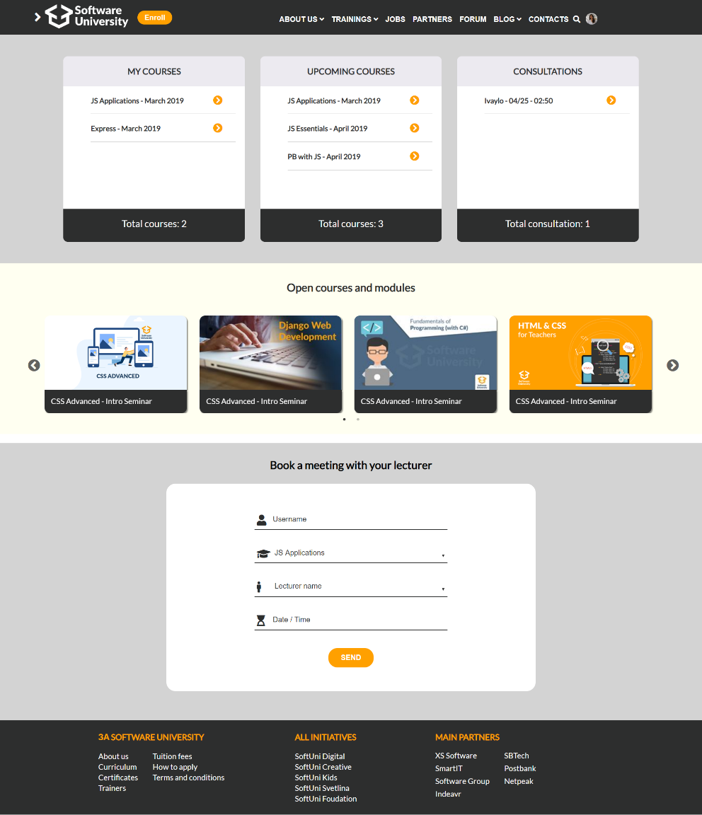

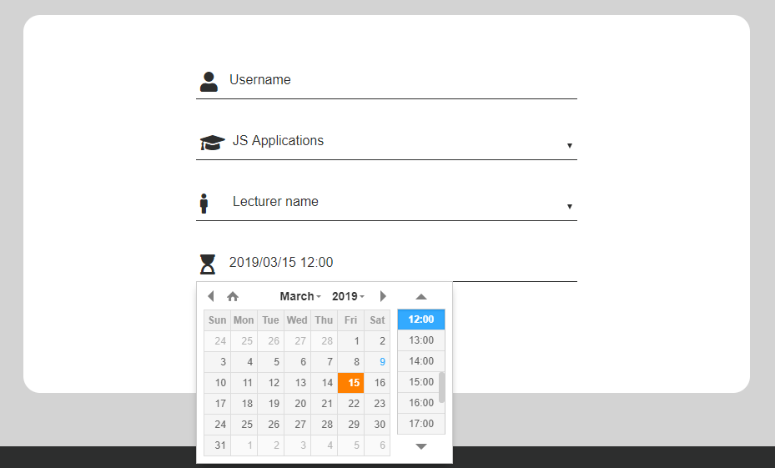

You can use the skeleton and upgrade it with **jQuery plugins** of your choice. Here is what we suggest.

## Slider Plugin

Sliders allow users to make selections from a range of values - so it is the perfect way to show our open courses. Sliders reflect a range of values along a bar, from which users may select a single value. There are many options to use slider - you can write it by yourself or you can use plugins.

For the slider section you can use [**Slick Slider**](http://kenwheeler.github.io/slick/). See how to integrate it in your project in the [**[Usage]**](http://kenwheeler.github.io/slick/) section.

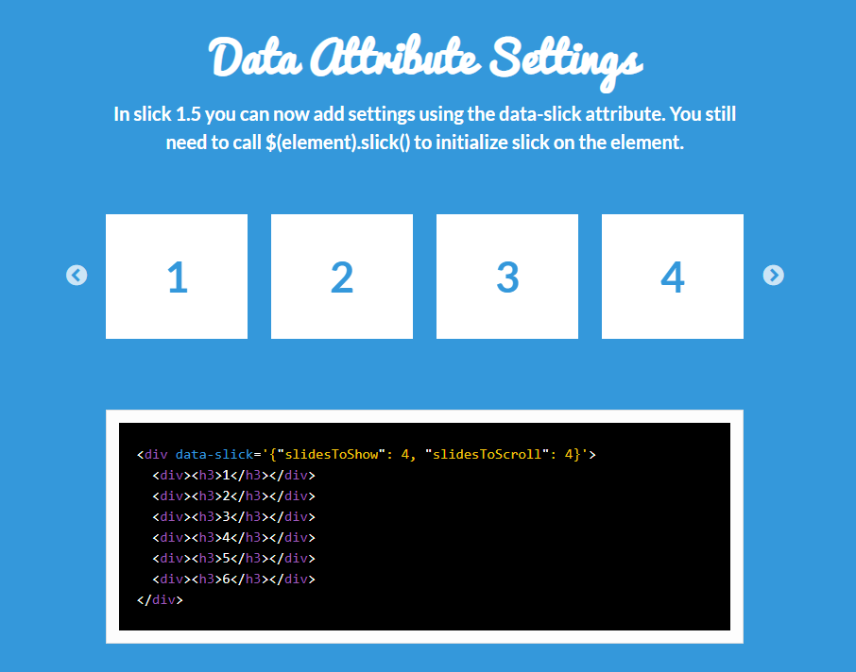

## DateTimePicker Plugin

The **DateTimePicker** plugin handles both date and time. For the **[Time]** input filed in the form you can use the following plugin: <https://xdsoft.net/jqplugins/datetimepicker/>

**Note:** Use the inline version with the white theme and modify it if it's needed.

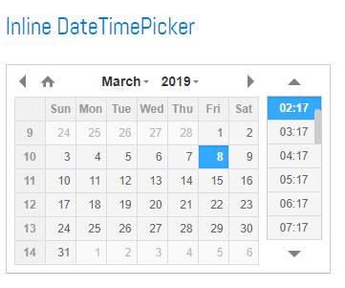

## Add some functionality

You can add some validations in your form like the following:

* **Username validation:** A valid username **starts with a letter** and can onlycontain **letters**, **digits** andunderscores “_”. It cannot be **less than 3 or more than 25 symbols** long.
* **Lecturer validation:** Should be one of the lecturer names.
* The form **can't be** send without filling all input fields.

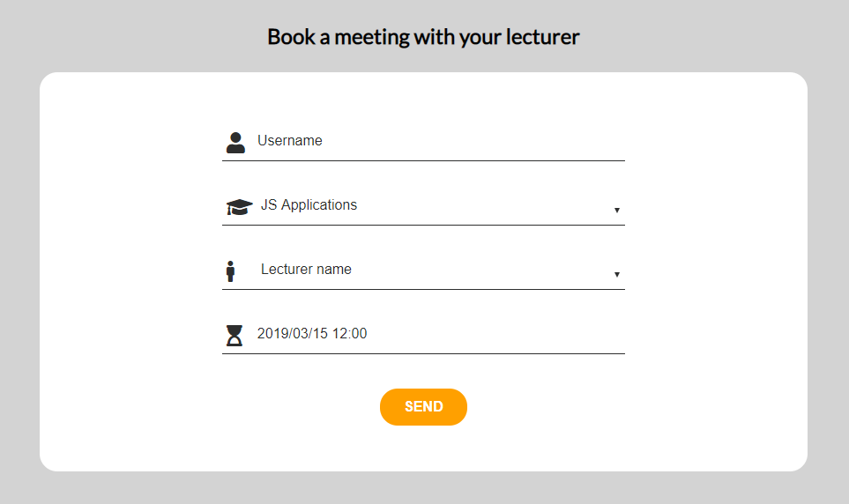

After successful filled form the meet should be displayed in the **[Consultations]** section in the following format:

"{lecturerName} – {date} – {hour}"

## Petals falling animation

The winter is not here anymore so we don't need the snowflakes. (Ivo will think about some **smeshka** here).

You can use the following plugin: <https://www.jqueryscript.net/animation/jQuery-Plugin-For-Sakura-Petals-Falling-Animation-Sakura.html>

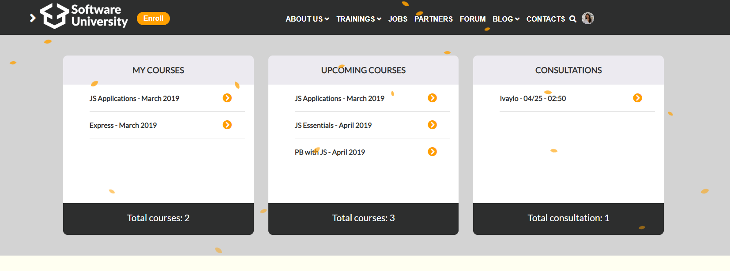

## Notifications

[**Notify.js**](https://notifyjs.jpillora.com/) is a jQuery plugin to provide simple yet fully customisable notifications.

